* **Project Preproposal**

1. **Project Title :** Rover
2. **Team :** Tech champs
3. **Team ID :** 8
4. **Project Team:** 1 Ratnavalli Avasarala

2 Sindhuja Thoutula

3 Harish Chandra Jyoshi

4 Sai Nagarjuna Kolla

* Augmented reality in tourism has a great potential to enhance traveller’s experiences. Tourism industry stands firmly on four whales: accommodation, transport, food and tourist attractions.
* **Motivation:** Travelling is all about a perfect planning and acquiring a best travel experience in less time. Difficulties faced by the travellers in planning the tour and during their travel like the language barrier and the food and transport facilities has motivated us to develop an app with all the requirements integrated, which would help them to overcome these and give a best travel experience.
* **Uniqueness:** This web application has all the data regarding the facilities and requirements for the travellers in a single platform.
* **Objective:** Our idea is to develop a web application for a particular tourist attraction and implement augmented reality on it for a better touring experience by integrating various facilities on a single platform.
* **System Features:** Using AR to support visitors in their native languages, offer maps and guides for specific niche audiences to get info about nearby restaurants and accommodations, offer additional historical or cultural context to an experience, show how their destinations would appear in a different season, or create educational games to learn about an area’s history and wildlife or to entertain children on long drives. Travellers will use AR technology to choose their destinations and activities before and during their trip. Ultimately, they will experience planning and travelling in a much more interactive and enriching way that will feel like a journey of its own.

**Project plan :**

* **Prioritized Features/Technologies :**  1**.** Weather API

2.Geo location

3.IBM conversation API

4.IBM Watson

5.google translator API

* **Schedule for the 3 increments** :

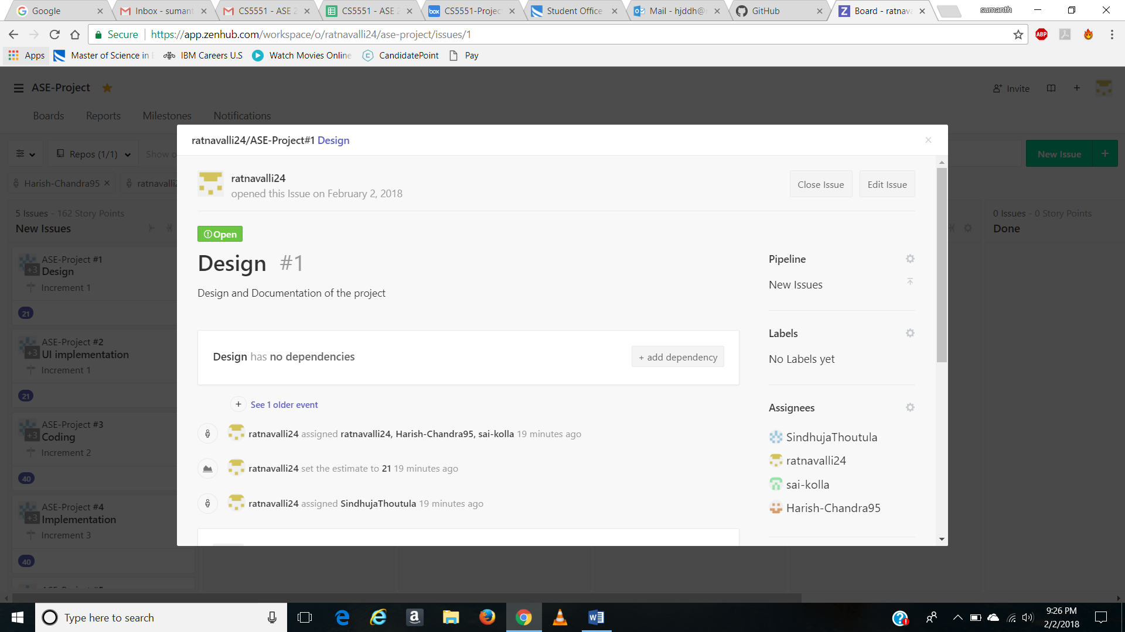

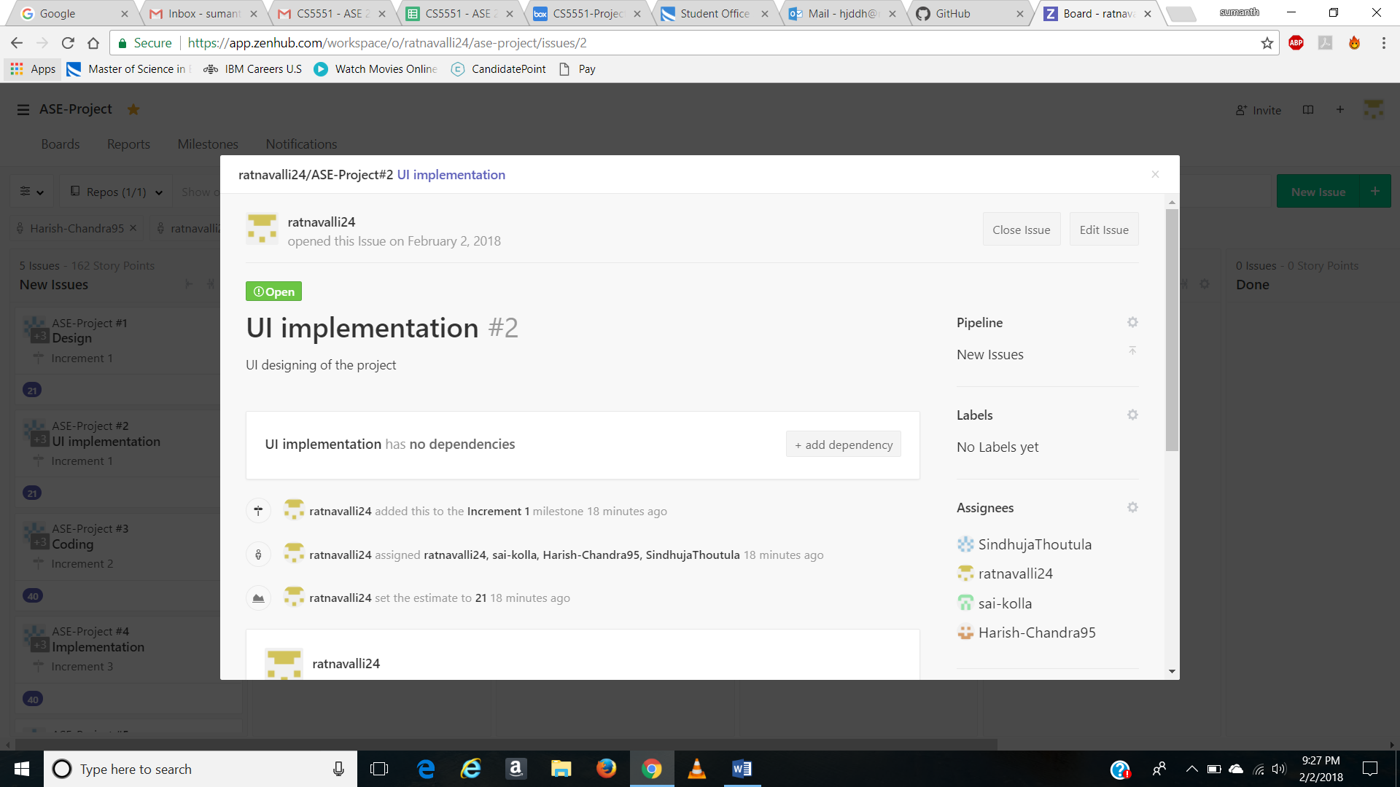 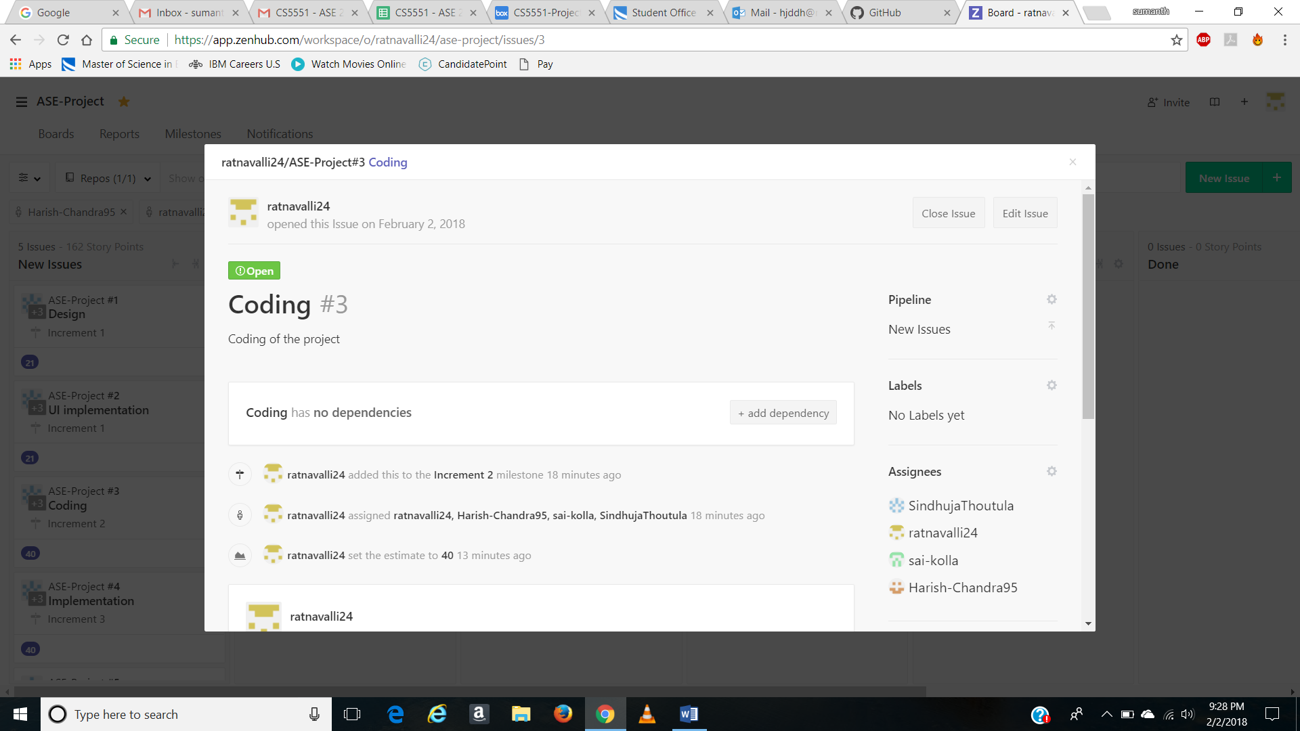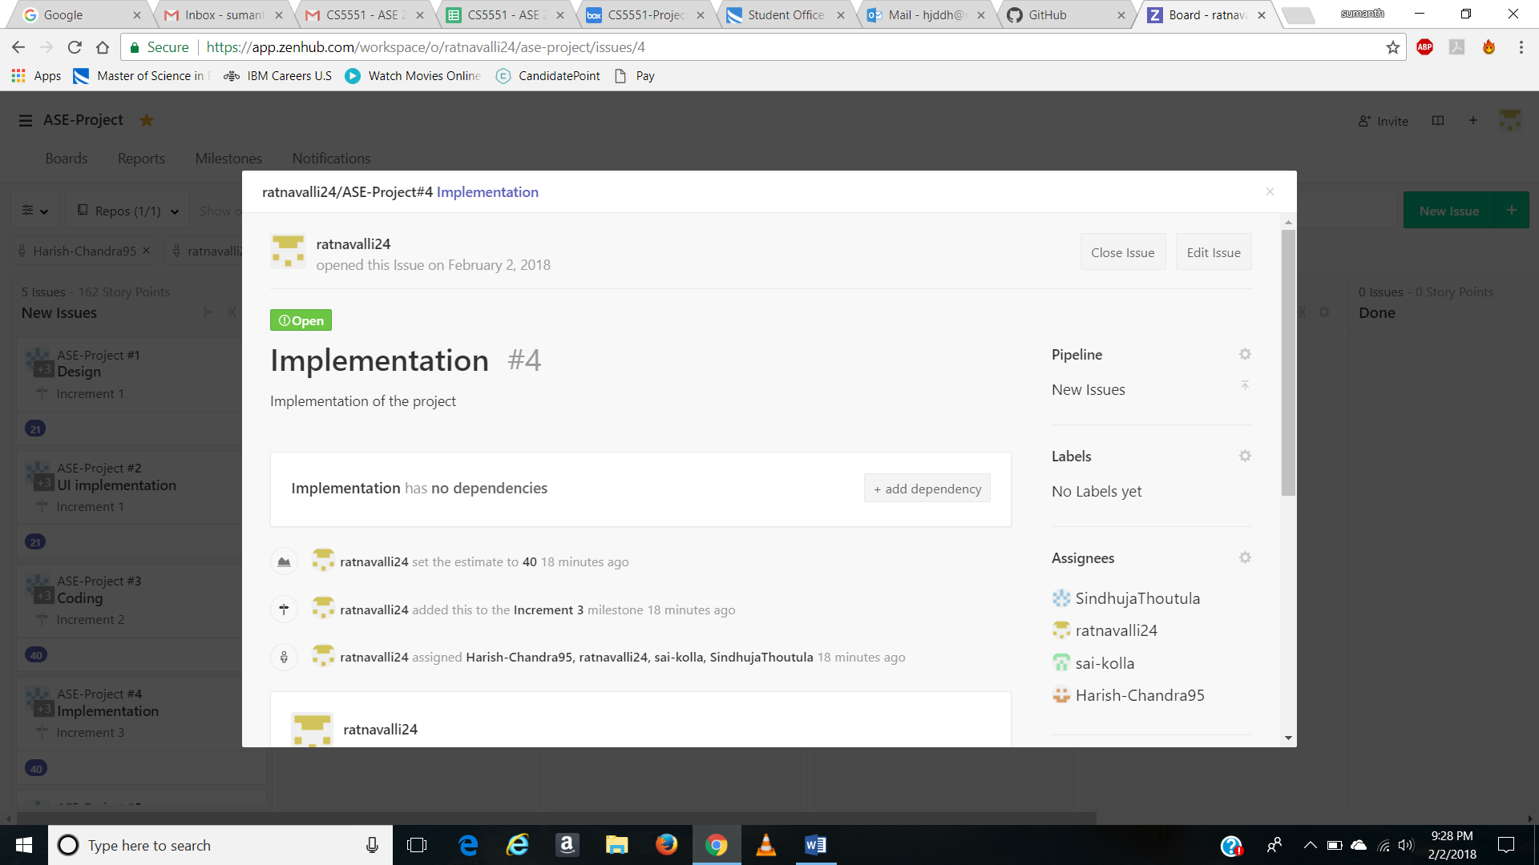

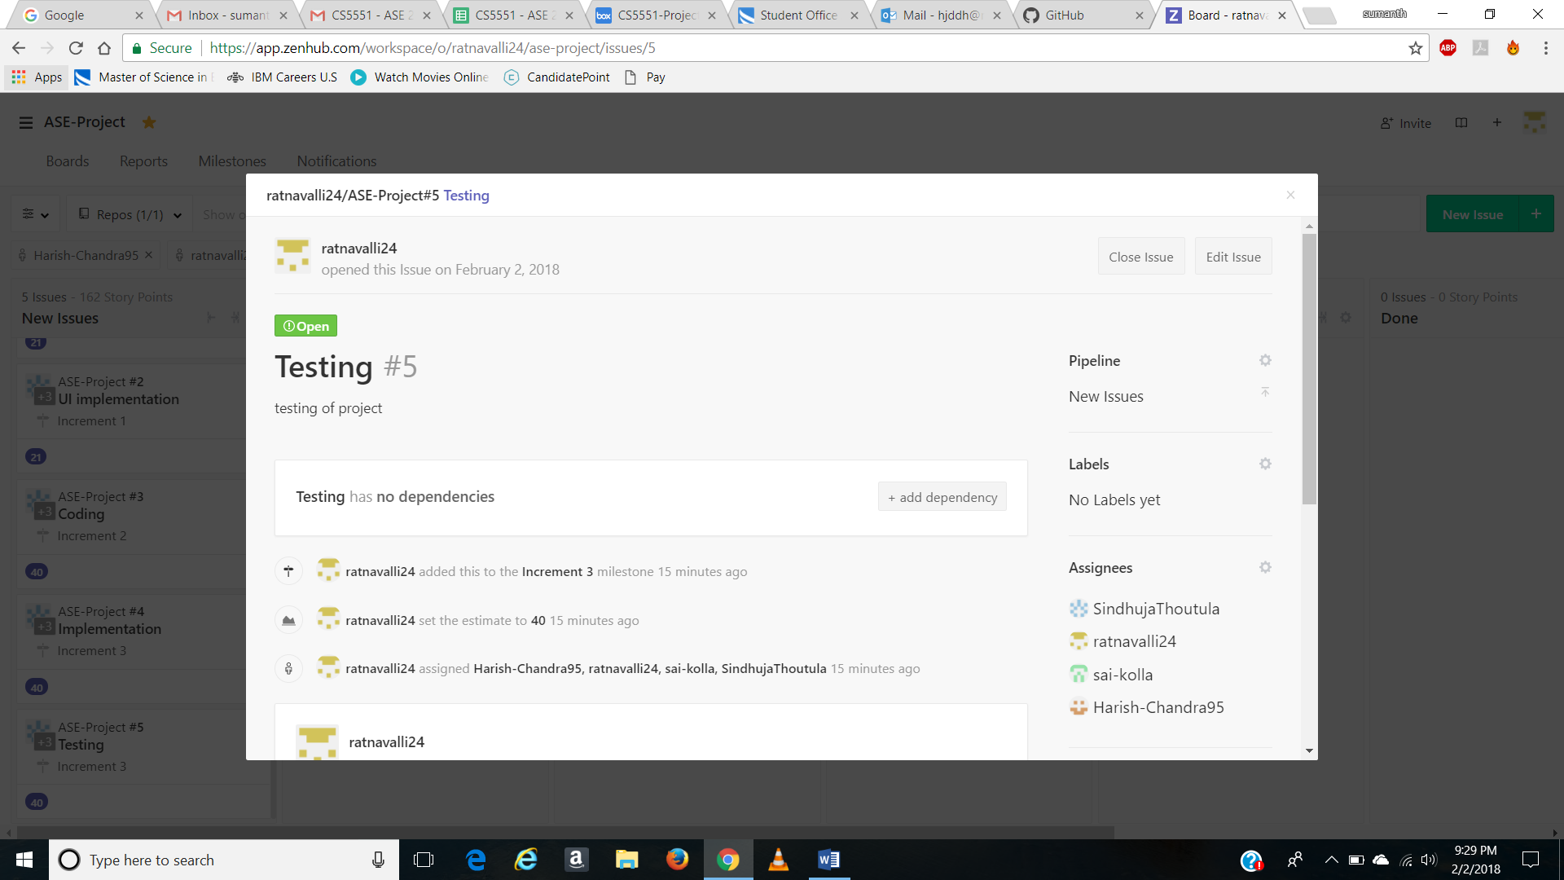

* **Burndown Chart :**

**Increment 1**

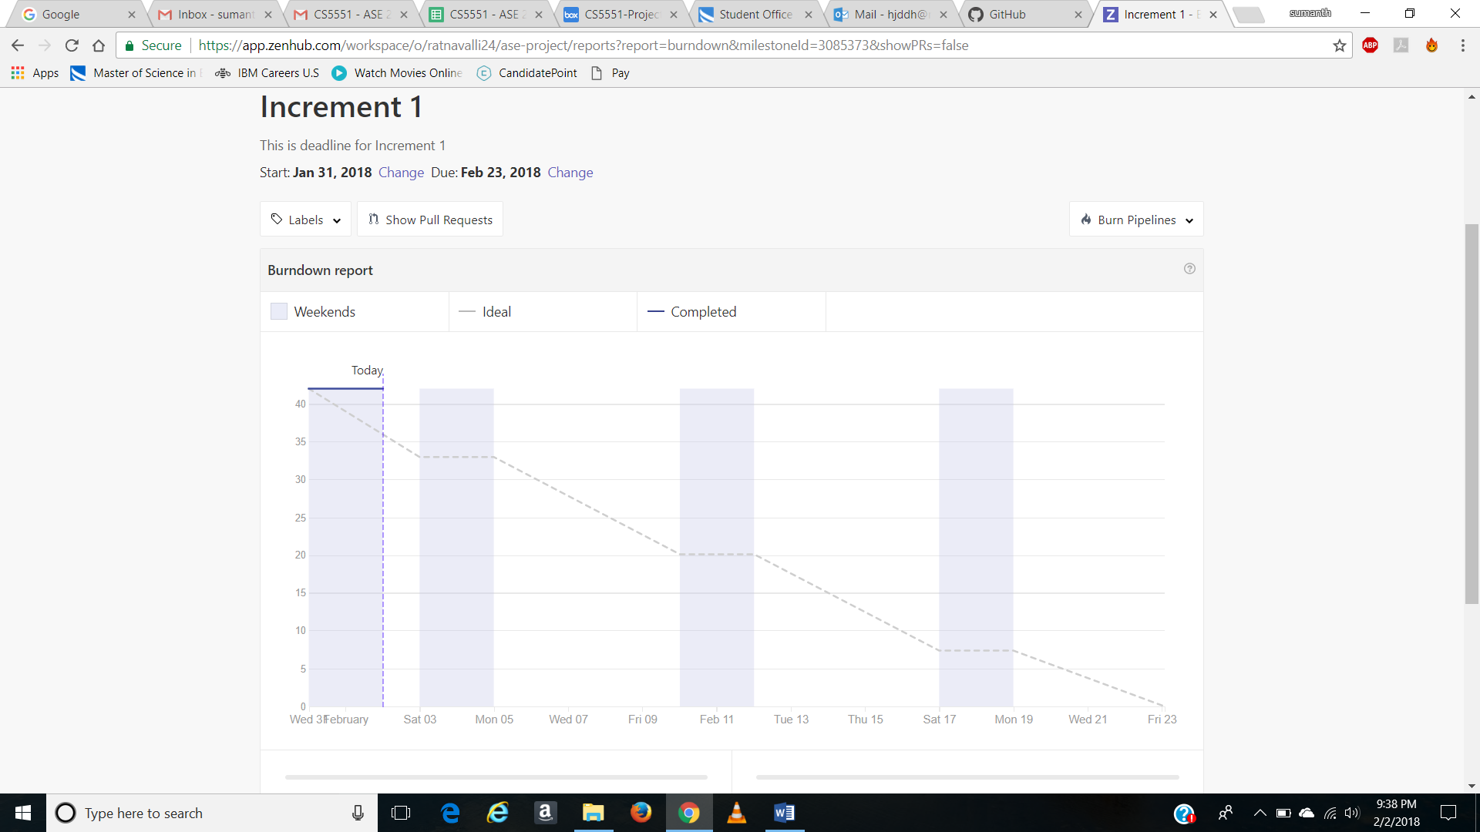

**Increment 2**

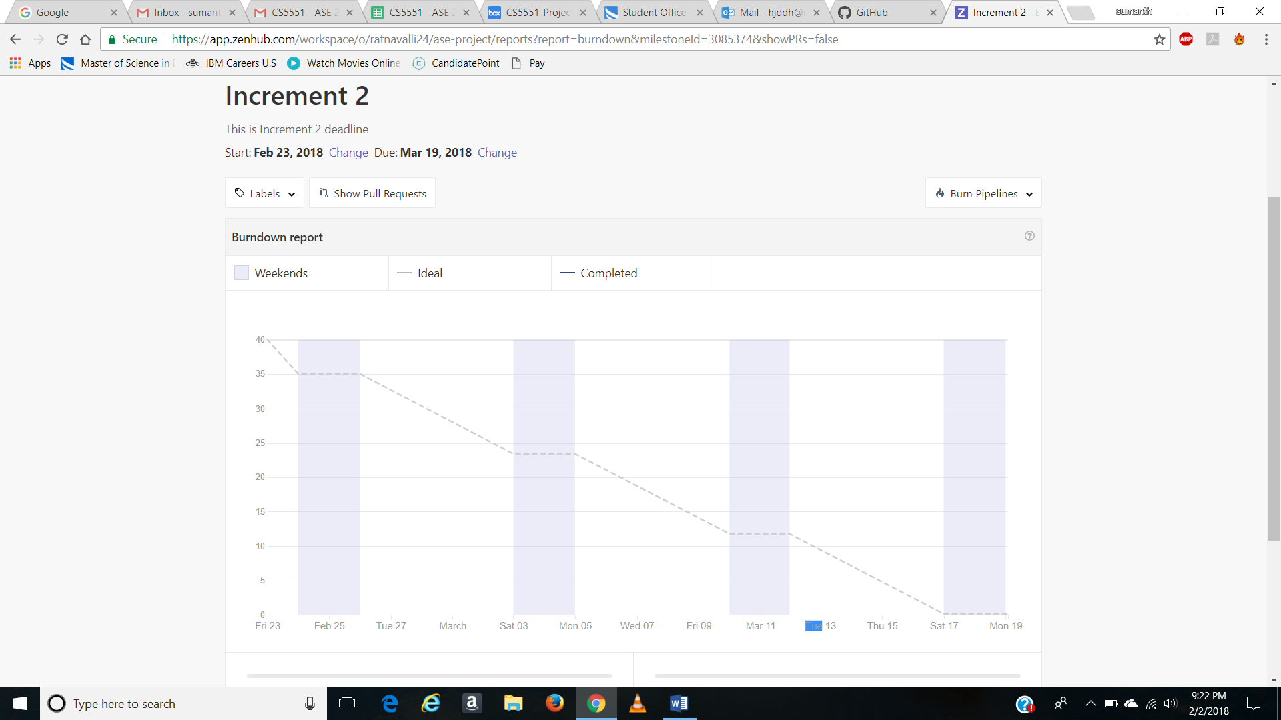

**Increment 3**

